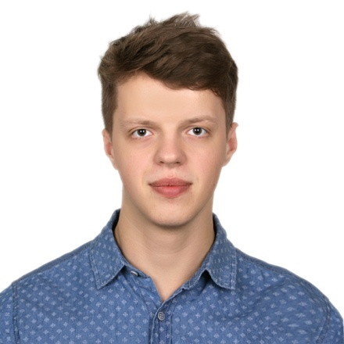**HALETSKI PAVEL**

Date of birth: 10 August 1991

Gender: male

Nationality: Belarus

Cell phone: +375 29 127 52 24

Email: [haletski.p@gmail.com](mailto:haletski.p@gmail.com)

Skype: [haletski.p@gmail.com](mailto:haletski.p@gmail.com)

# Skills and experience

**Сompany: «Godel Technologies Europe»**

Project: «IDO insurances»

Dates: December 2017 – present time

Duration: 1.7 years

Summary: Web application about retailing insurances which is leading distributor of insurances and household financial services in England.

Participation: Developing new features for new brands and extend functionality. Application provides possibilities to insure home, housekeeping etc. Self service center allows to register and select desired product with a collection of conditions and insurances. Bug fixing making little improvements in existing system.

Stack of technologies: ASP.NET MVC 5, WEB API, Security, OWASP, JWT, C#, SignalR, IIS, Application Insight Logging, HTML, CSS, Sass, JQuery, JavaScript, Ajax, NodeJs, Gulp, JSON, NUnit, TDD, SOLID, ReSharper, Functional Tests, Selenium Web Driver, Team City, Unit Testing, Visual Studio 2015, Bitbucket, Atlassian JIRA, Confluence, Agile.

Project: «Trello monitor»

Dates: September 2017 – December 2017

Duration: 4 month

Summary: Application for synchronization data from Trello Boards and retrieving statistics for analytic tool for building varies kind of reports at web-application and creating different kinds of charts in splunk. Project is based on using microservice architecture. Team: 1 PM, 5 Developers Participation: Writing microservices for processing data from another microservices and send reports to the splunk. Configure reports in splunk for the subsequent creation of charts and tables based on logs. Developing of new features with testing. Stack of technologies: C#, ASP.NET Core 2.0, VS2015, Resharper, MSSQL Server, REST API, Swagger, Postman, Splunk, Docker, Logging, TDD, xUnit and subsystem tests, Jira, Teamcity, Agile.

Project: «Admin light CRM»

Dates: August 2017 – September 2017

Duration: 2 month

Summary: Desktop application for accounting products and other analytic processes

Participation: Developing new features and extend functionality. Application stands for accounting products and providing another analytic information about company activities. Bug fixing making little improvements in existing system.

Stack of technologies: C#, WPF, .NET Framework, ADO.NET, MSSQL Server, Entity Framework, NUnit, TDD, SOLID, ReSharper, Functional Tests, Team City, Unit Testing, Visual Studio 2015, Atlassian JIRA, Confluence, Agile.

# EDUCATION

**Belarusian State University**

**of informatics and Radioelectronics (BSUIR)**

Field of study: Software information systems

Major: Software Engineer

Dates: 2015-2018

# LANGUAGES

English language

• Speaking ability –upper-intermediate;

• Writing ability – intermediate;

• Perfect reading and understanding of documentation and another texts.

# ADDITIONAL INFORMATION

Operation systems: Microsoft Windows, Linux, IOS;

Browsers: IE, Edge, Google chrome, Opera, Mozilla firefox;

Database: Microsoft SQL server;

Programming: C#, ASP.NET MVC 5, ASP.NET Core, Entity framework, JavaScript, NodeJs, EcmaScript, JQuery, HTML5, CSS3, Sass, Docker;

Others: Microsoft visual studio, VS code, Adobe Photoshop

Books: «C# and .net framework» by Andrew Troelsen,

«CLR via C#» by Jeffrey Richter

# ABOUT ME

I lived in USA around one year and got enough experience in communication with the native language speakers. Also I am hard-working, honest team player and good timekeeper, well-trained person and always willing to learn new skills. I like to travel and to have an active lifestyle. As per my hobbies I like riding a bike and snowboarding. At my spare time I prefer to spend a lot of time for self-education and reading books.